Bulmor Airground Technologies

Contents and contact details

1. Bulmor Airground Technologies – A subsidiary of the Bulmor Group
2. Bulmor presents solutions for PRM boarding

2.1. SideBull 2.0
2.1.1. Advantages of the SideBull 2.0
2.1.2. Technical details
2.1.3. Safety first!
2.1.4. SideBull Ambulift in action around the world
2.2. FrontBull
2.2.1. Advantages of the FrontBull
2.2.2. Technical details
2.2.3. Features
2.2.4. Images

Contact:
Bulmor industries GmbH
Kickenau 1
A-4320 Perg

P: +43 7262 58397
F: +43 7262 58397 11
E: info@bulmor.com
Website: www.bulmor.com, www.bulmor-airground.com

Press contact:
Bulmor Airground technologies GmbH
Konrad Gruber
E: k.gruber@bulmor.com
M: +43 664 81 30 164

Digital documents: www.bulmor-airground.com/presse

1. Bulmor Airground Technologies – A subsidiary of the Bulmor Group

Bulmor Airground Technologies GmbH, a wholly owned subsidiary of the Bulmor Group, develops and markets bespoke passenger-boarding vehicles and VIP boarding lounges. Bulmor Airground Technologies – a global success story since 2002.
If the latest statistics from the International Air Transport Association (IATA) are correct, the number of air passengers in 2016 reached 3.7 billion: a record high. One possible explanation is that flying has never been cheaper.

Global passenger numbers are even expected to reach 7.2 billion by 2035 – twice the number who flew in 2016.

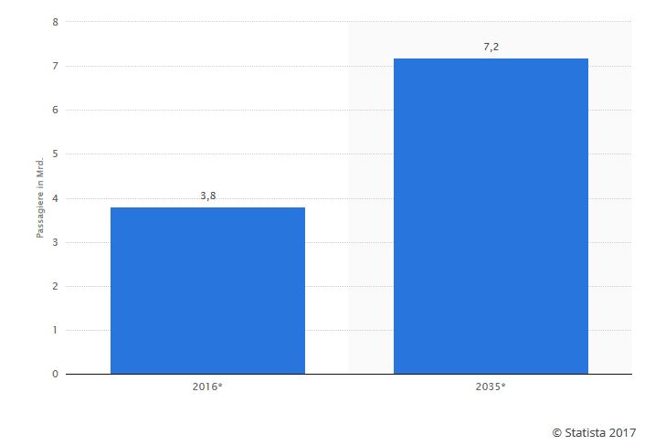
Predicted global passenger numbers 2016-2035 (in billions).

However, as passenger numbers rise, so too does the number of passengers with reduced mobility. Bulmor has identified this trend early and has prepared the appropriate solutions.

2. Bulmor presents solutions for PRM boarding

The number of air passengers with reduced mobility (PRM) who find it difficult to cover longer distances at airports and to use outdoor passenger stairs continues to rise around the world. This trend poses a great challenge to airports and to their PRM assistance providers. Safety, efficiency and flexibility are key factors in the ground handling process. The SideBull was developed to ensure short turn-around times as well as comfortable boarding/disembarking and transfer processes for air passengers.

2.1. SideBull 2.0

Developed in 2002 alongside Lufthansa LEOS, the patented and unique SideBull concept is an ambulift based on the chassis of a sideloader. Thanks to support from FRAPORT (Frankfurt Airport), it was later modified to meet the needs of passengers with reduced mobility. The SideBull Ambulift sets new standards in PRM ground handling and is used at numerous international hubs and mid-sized airports.

Generation 2.0 of the lift vehicle was developed between 2013 and 2015, based on user feedback and with the assistance of Careport (PRM service provider in Zurich) and VIAS (Vienna Airport) in particular.

2.1.1. Advantages of the SideBull 2.0

  - Functional one-person operation. The driver’s seat is integrated directly into the passenger cabin, so there is no spatial separation between the driver and the passengers.
  - Time-saving thanks to manoeuvrability while the cabin is being raised and when it is raised. Dock in 25 seconds.
  - No telescopic supports necessary. Automatic hydraulic levelling system.
  - Suitable for use with all aircraft types. Due to the specially designed front platform and the absence of a separate driver’s cab, the vehicle can dock with all wide-body aircraft as well as with modern short-range aircraft with low door threshold heights.
  - Docking with busses. The SideBull can dock directly with most minivans and PRM buses, meaning that passengers do not need to contend with any stairs.
  - Safe and convenient boarding. The passenger cabin can be lowered completely to the ground alongside the chassis. This speeds up the entire boarding process when several PRMs need to be brought into the cabin

2.1.2. Features

  - PRM-friendly passenger cabin with large windows and 95-cm wide leaf door
  - Sideloader steering system for reliable steering manoeuvres in the tightest of spaces
  - Independent suspension on half-axles
  - Hydraulic comfort suspension system on each wheel
  - Three-stage lift mast, suitable for passenger transport
  - Independent heating and air conditioning system
  - Vertical lift for quick and flexible transfer of small groups of passengers

2.1.3. Technical details

  - Wind stability up to 100 km/h
  - Extendable front platform with rotating deck tongue and swivelling/telescoping side rails
  - Lifting height: 5.7-8.1 m (depending on type and position)
  - Engine/drive: 100 kW (diesel) / hydrostatic drive
  - Driving speed: 25-30 km/h, 2 km/h (crawler gear)
  - Loading capacity: 1500 kg / max.15 people; space for 4-5 wheelchairs

2.1.4. Safety first!

The safety of passengers, operators and aircraft was the most important concern when developing the SideBull. The vehicle is designed and built in accordance with the EU Machinery Directive as well as European standards EN1915 1-4 and EN12312-14 and has undergone a type examination by the independent testing and certification body DGUV (Deutsche gesetzliche Unfallversicherung [German Statutory Accident Insurance], notified body 0417). A safety control system ensures that all driving and operating movements are safe and comply with the relevant standards and rules for ground support equipment.

All load-bearing components of the lift unit are designed with a tenfold margin of safety. The lift chains are doubled and are also monitored by safety sensors, check valves on the lift cylinders prevent the cabin from dropping in the event of a loss of hydraulic pressure, and between the cabin and the vertical lift, there is a shut-off bar that serves as protection against crushing and shearing. Electric rail and door locks with an emergency opening function serve as fall protection. The SideBull has been successfully tested in winds of 100 km/h and higher.

A video system that automatically switches between various cameras shows all areas that are not directly visible when docking and lowering the cabin.

2.1.4. SideBull Ambulift in action around the world

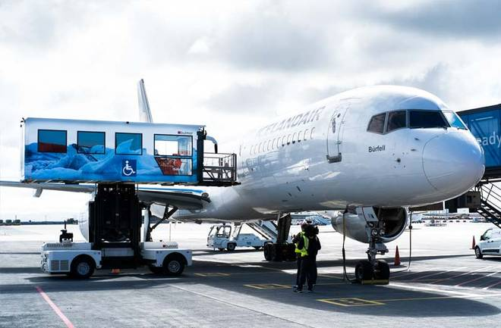
PRM Ambulift at Keflavík Airport (Photo: Bulmor)

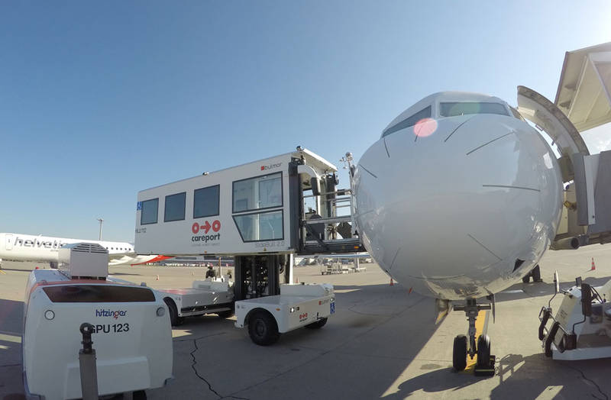
Ambulift – Zürich Airport (Photo: Jens Bayard)

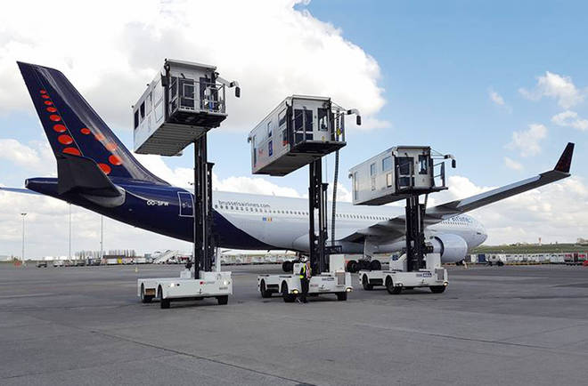
Ambulift at Brussels Airport (Photo: Bulmor)

2.2. FrontBull

In response to the growing global market for aircraft ground support equipment and the related increase in the number of passengers with reduced mobility, Bulmor developed the SideBull for medium-sized airports and international hubs. Now Bulmor is able to present the new FrontBull: a high-quality solution for small and regional airports based on a bespoke concept. The USP – and great strength – of the FrontBull lies in its compact size and robust properties.

2.2.1. Advantages of the FrontBull

  - A concept based on proven sideloader technology. Not only does the cabin sit on the chassis with running gear and drive elements, but compact external dimensions can be combined with a roomy cabin interior and large running gear framework.
  - One-person operation with driver's seat in the passenger cabin. Constant contact between driver and passengers is possible.
  - Time-saving thanks to manoeuvrability while raising the cabin and with the cabin raised.
  - No telescopic supports necessary. Automatic hydraulic levelling system.
  - Compatible with all aircraft types (up to A340). Aircraft doors can be opened inside the platform area.
  - Docking with busses is possible.
  - Passenger cabin can be lowered fully to the ground.

2.2.2. Features

  - PRM-friendly passenger cabin for 2-4 passengers with large windows and exceptional visibility for the driver and passengers
  - 100-cm wide sliding door for optimum utilisation of space on the platform and in the cabin interior
  - Hydraulically extendable platform, hydraulically extendable railings
  - Proven sideloader steering system for a turning circle of less than 4.7 m
  - Optional comfort suspension
  - Independent heating and air conditioning system

2.2.2. Technical details

  - Environmentally friendly electric drive. Robust lead-acid battery with 48 kWh for 4-6 hours of usage. Optional li-ion battery allows quick opportunity charging
  - 2x17 kW AC traction drive motors for speeds of 15 km/h
  - Lifting height: up to 5.7 m
  - Environmental conditions: -20°C to +40°C
  - Wind speed up to 75 km/h
  - Additional ramp to improve accessibility for electric-wheelchair users
  - Airline rails for fixing the wheelchairs or stretcher
  - Vehicle lighting with LED technology

2.2.4. The new FrontBull

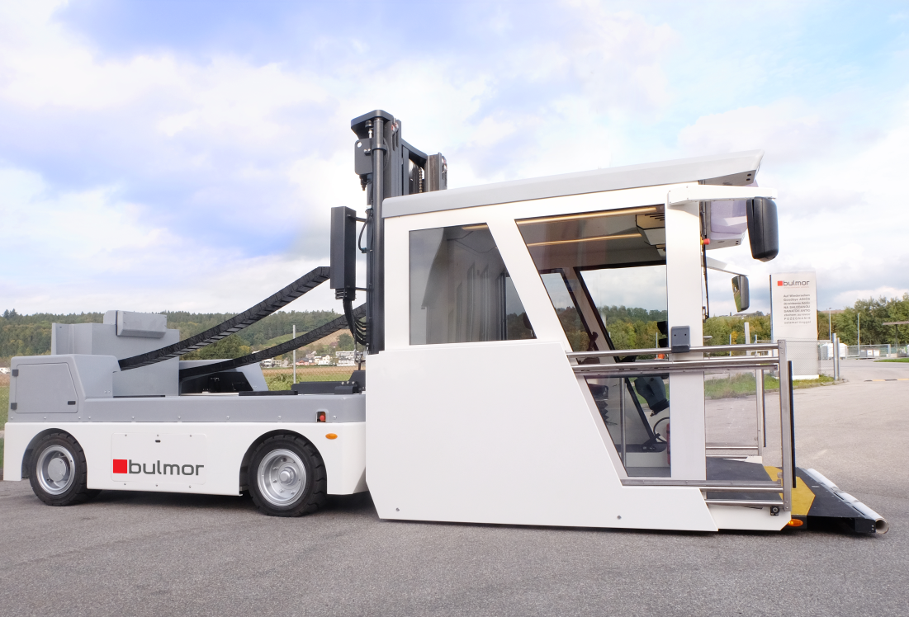

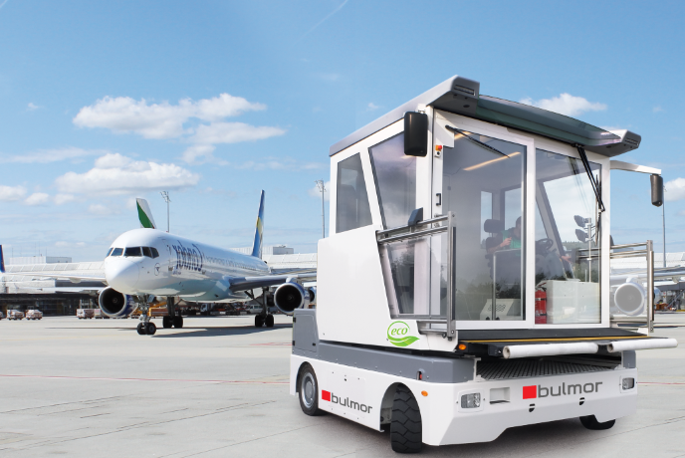
Photo: FrontBull Bulmor
Geringfügige technische Änderungen vorbehalten
Position für Tragstuhl
Tür Öffnung
Platz für weitere Klappsitze
Position für 4-5 Rollstühle
Optionale hintere Türe
4 Standard-Klappsitze
Stehhöhe 2000-2100mm

http://www.liligo.de/reisemagazin/neue-iata-statistik-30304.html – Accessed 21/09/2017
https://de.statista.com/statistik/daten/studie/374860/umfrage/flugverkehr-entwicklung-passagiere-weltweit/ – Accessed on 21/09/2017

