Quick and easy:
Bulmor presents the new compact Ambulift for regional and small airports
The Austrian sideloader specialist Bulmor is unveiling their latest innovation at Munich’s inter airport Europe exhibition: the compact FrontBull Ambulift for regional and small airports. The premium ground support vehicle has been specially developed for boarding passengers with reduced mobility.

Compact and comfortable
The new FrontBull is especially compact and turns on a radius of only 4.65 m. It also offers plenty of room for comfort. A space-saving sliding door enables the interior to be used to its full potential and provides space for two wheelchairs and one attendant each. There is ample space for the operator and the passengers, who can enjoy an excellent view through the large windows. Additional storage space is also available as the driver’s area is in the passenger compartment, which also means that no additional staff are required.

Programmed for international success.
Even before the FrontBull was developed, Bulmor had achieved international success with its Ambulift, which has been in continuous production for many years now. The worldwide market for aircraft ground support equipment is growing, as is the number of flight passengers with limited mobility. Bulmor was early to recognise this trend and achieved a technological milestone in PRM transportation with the SideBull for medium-sized and large airports, as well as international hubs. With the FrontBull, the Austrians have taken their successes one step further. “The new FrontBull retains all the same benefits of the SideBull, but has been specially designed for smaller airports,” explains Dr Walther Pitscheneder, Bulmor CEO. “The innovative concept of the machine is based on the Bulmor Group’s decades of experience with side loading forklift trucks and multi-directional reach trucks, as well as the knowledge that we have gathered from over 15 years of working in the PRM industry. The FrontBull combines user-friendliness with compactness and robustness, and is also environmentally friendly.”

The benefits at a glance:
- Environmentally friendly electric drive: robust lead-acid battery with 48 kWh for 4-6 hours of use.
- Capacity: 2-4 passengers
- Lift height: up to 5.7 m
- Environmental conditions: -20 to +40°C, wind speeds of up to 75 km/h
- Lifting and driving without supports enables speedy turnarounds
- Two 17 kW three-phase AC drive motors for a maximum speed of 15 km/h
- Ensures swift and secure docking with every type of aircraft

Unparalleled Austrian robustness
Passengers not only benefit from maximum comfort, they also benefit from the FrontBull’s robust and stable construction. Because the cabin can be set directly onto the ground, passengers are able to board comfortably. There are additional ramps for electric wheelchairs. As soon as the optimum distance from the fuselage is reached, the platform and railings switch off automatically and the aeroplane doors can be opened from inside the platform. The generous windows not only provide the operator with the best possible perspective, but also provide the passengers with a good view. Roomy doorways and the operator’s proximity to the passengers are other features that contribute to passenger comfort.

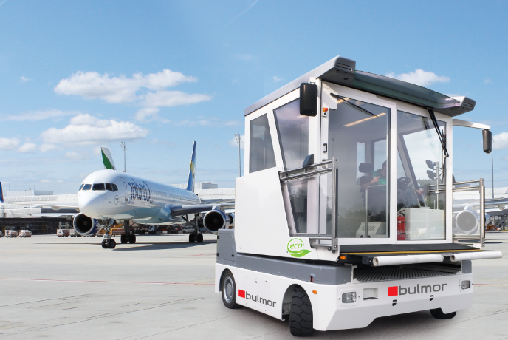
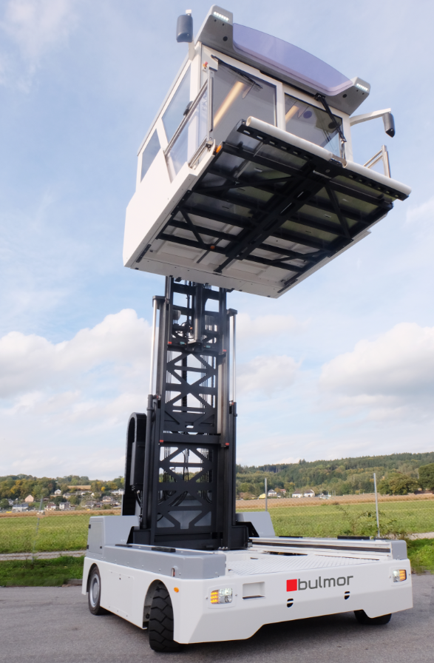
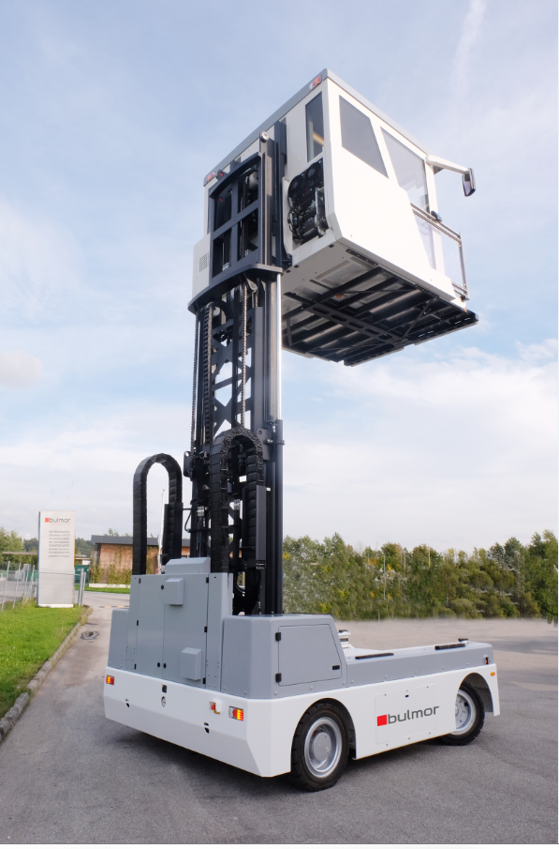
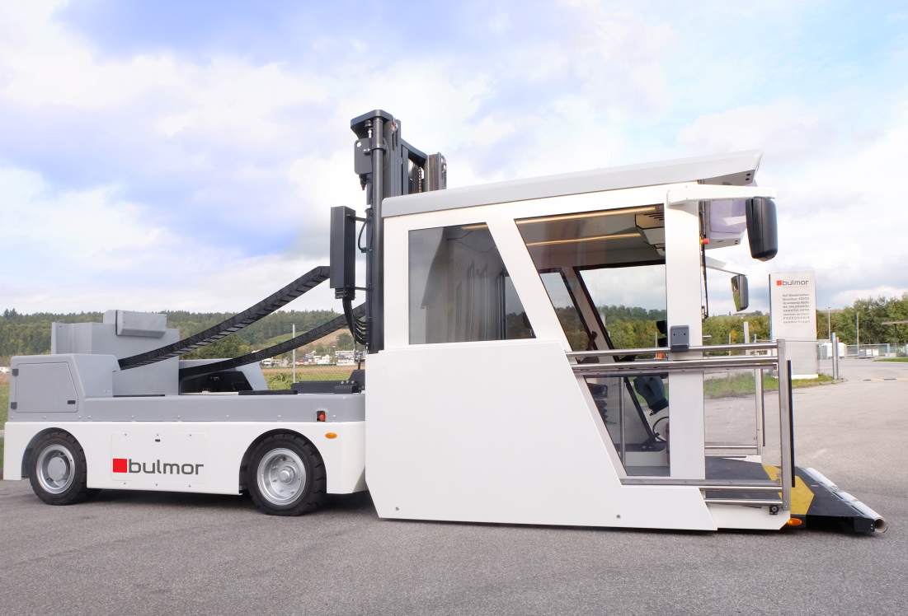

Foto: FrontBull Bulmor

Contact:
Bulmor industries GmbH
Kickenau 1
A-4320 Perg

P: +43 7262 58397
F: +43 7262 58397 11
E: info@bulmor.com
Website: www.bulmor.com, www.bulmor-airground.com

Press contact:
Bulmor Airground technologies GmbH
Konrad Gruber
E: k.gruber@bulmor.com
M: +43 664 81 30 164

Digital documents: www.bulmor-airground.com/presse

